**Q1)** 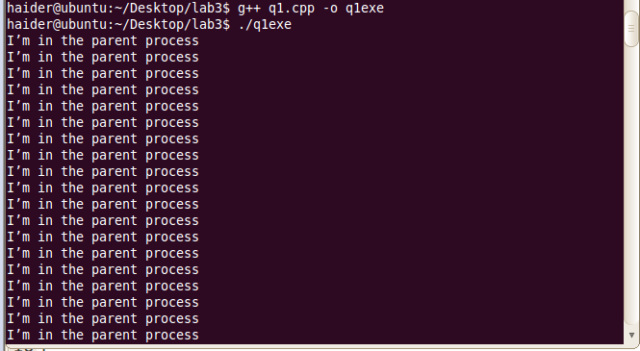

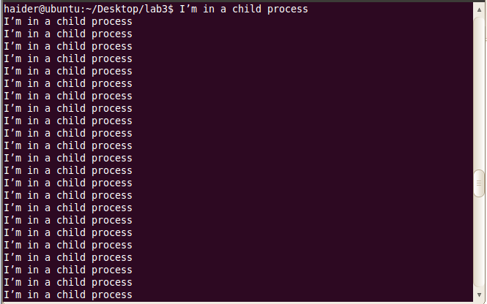

#include <stdio.h>

#include <sys/types.h>

#include<iostream>

using namespace std;

int main()

{

pid_t pid;

pid=fork();

if(pid==0){

for(int i=0; i<100; i++)

cout<<"I’m in a child process \n";

}

else if (pid>0){

for(int i=0; i<100; i++)

cout<<"I’m in the parent process \n";

}

else

{

cout<<"Error \n\n";

}

return 0;

}

**Q2)**

#include <stdio.h>

#include <sys/types.h>

#include <iostream>

#include <string>

#include <stdlib.h>

using namespace std;

int main(int argc, char *arg[])

{

string check=arg[argc-1];

int sum=0;

if(check=="$")

{

int j=1;

int *arr=new int[argc-2];

for(int i=0; i<argc-1; i++)

{

arr[i]=atoi(arg[j]);

j++;

}

pid_t pid;

pid=fork();

if(pid==0)

{

cout<<"I’m in a child process1, ";

for(int i=0; i<argc-2; i++)

{

sum+=arr[i];

}cout<<"sum is:"<<sum<<endl;

}

else if (pid>0)

{

cout<<"I’m in the parent process1"<<endl;

pid=fork();

if(pid==0)

{

float avg=0;

float sum=0;

cout<<"I’m in a child process2, ";

for(int i=0; i<argc-2; i++)

{

sum+=arr[i];

}

for(int i=0; i<argc-2; i++)

{

avg=(sum/(argc-2));

}cout<<"avg is:"<<avg<<endl;

}

else if (pid>0)

{

cout<<"I’m in the parent process2"<<endl;

pid=fork();

if(pid==0)

{

cout<<"I’m in a child process3, ";

int big=0;

for(int i=0; i<argc-2; i++)

{

if(arr[big]<arr[i])

{

big=i;

}

}cout<<"Largest:"<<arr[big]<<endl;

}

else if (pid>0)

{

cout<<"I’m in the parent process3"<<endl;

}

else

{

cout<<"Error3"<<endl;

}

}

else

{

cout<<"Error2"<<endl;

}

}

else

{

cout<<"Error1"<<endl;

}

}

else

{

cout<<"missing end character($)"<<endl;

}

return 0;

}

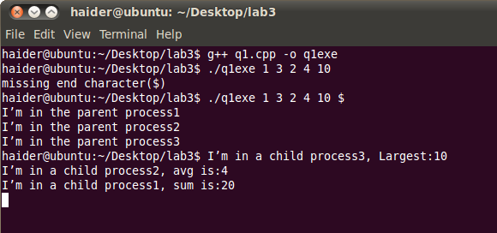

**Q3)**

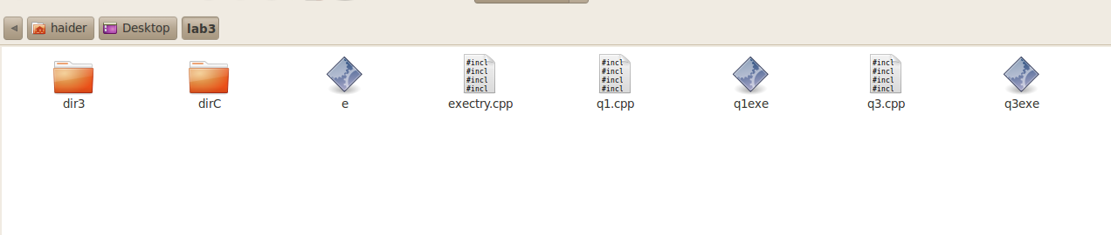Initially:

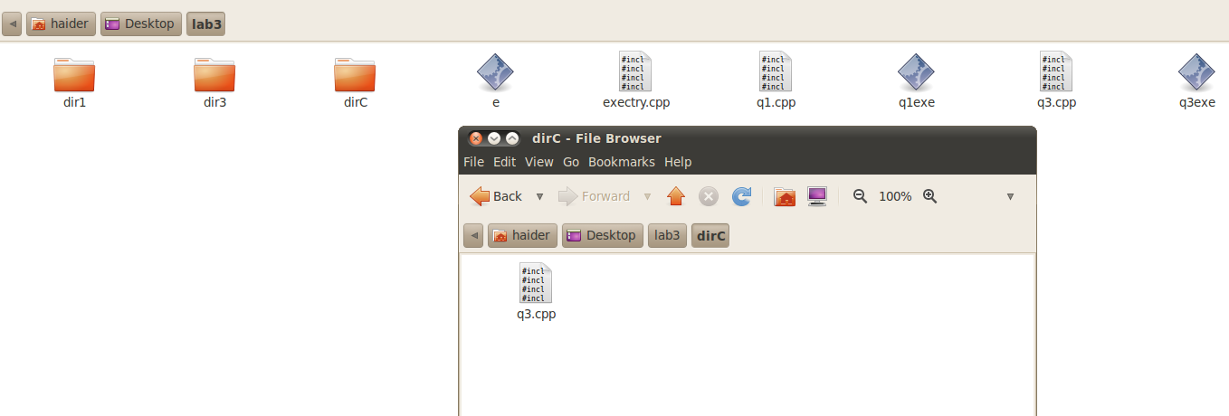After:

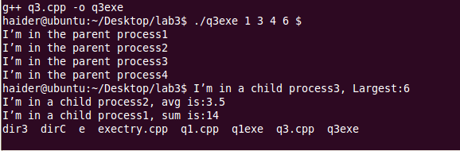

#include <stdio.h>

#include <sys/types.h>

#include <iostream>

#include <string>

#include <stdlib.h>

#include <unistd.h>

using namespace std;

int main(int argc, char *arg[])

{

string check=arg[argc-1];

int sum=0;

if(check=="$")

{

int j=1;

int *arr=new int[argc-2];

for(int i=0; i<argc-1; i++)

{

arr[i]=atoi(arg[j]);

j++;

}

pid_t pid;

pid=fork();

if(pid==0)

{

cout<<"I’m in a child process1, ";

for(int i=0; i<argc-2; i++)

{

sum+=arr[i];

}cout<<"sum is:"<<sum<<endl;

execlp("mkdir", "mkdir", "dir1", NULL);

}

else if (pid>0)

{

cout<<"I’m in the parent process1"<<endl;

pid=fork();

if(pid==0)

{

float avg=0;

float sum=0;

cout<<"I’m in a child process2, ";

for(int i=0; i<argc-2; i++)

{

sum+=arr[i];

}

for(int i=0; i<argc-2; i++)

{

avg=(sum/(argc-2));

}cout<<"avg is:"<<avg<<endl;

execlp("rmdir", "rmdir", "dir2", NULL);

}

else if (pid>0)

{

cout<<"I’m in the parent process2"<<endl;

pid=fork();

if(pid==0)

{

cout<<"I’m in a child process3, ";

int big=0;

for(int i=0; i<argc-2; i++)

{

if(arr[big]<arr[i])

{

big=i;

}

}cout<<"Largest:"<<arr[big]<<endl;

execlp("cp", "cp", "q3.cpp","dirC", NULL);

}

else if (pid>0)

{

cout<<"I’m in the parent process3"<<endl;

pid_t pid;

pid=fork();

if(pid==0)

{

cout<<"I’m in a child process4, ";

execlp("ls", "ls", NULL);

}

else if (pid>0)

{

cout<<"I’m in the parent process4"<<endl;

}

else

{

cout<<"Error4"<<endl;

}

}

else

{

cout<<"Error3"<<endl;

}

}

else

{

cout<<"Error2"<<endl;

}

}

else

{

cout<<"Error1"<<endl;

}

}

else

{

cout<<"missing end character($)"<<endl;

}

return 0;

}